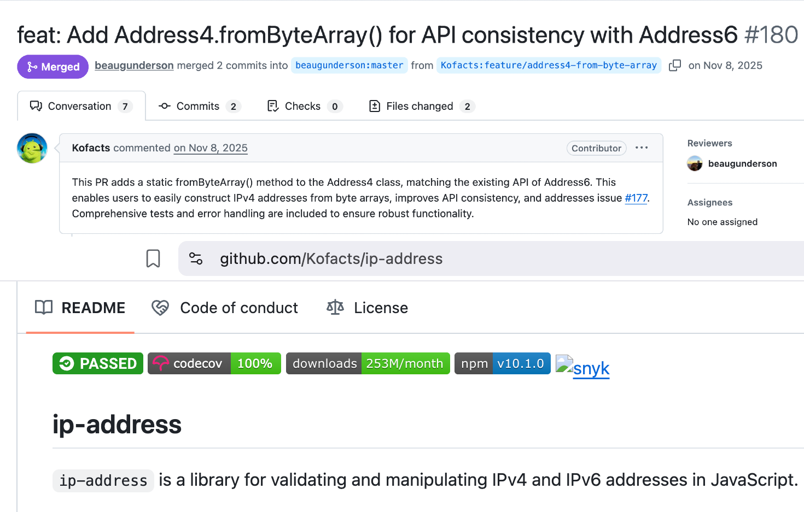

- ip-address (253M+ Monthly Downloads)
- Engineered foundational IPv4/v6 API parity to ensure network reliability for the core Node.js internet infrastructure.

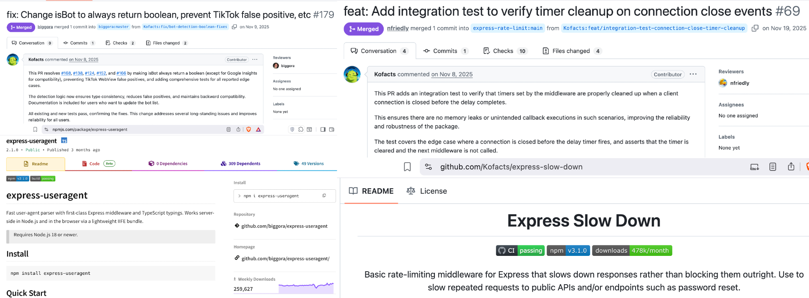

- express-useragent (1.1M+ Monthly Downloads): Patched critical analytics and bot-detection flaws to safeguard data integrity for over 1 million web applications.
- express-slow-down (478k+ Monthly Downloads): Architected security tests to prevent critical server resource exhaustion (DoS) vulnerabilities in high-traffic production environments.

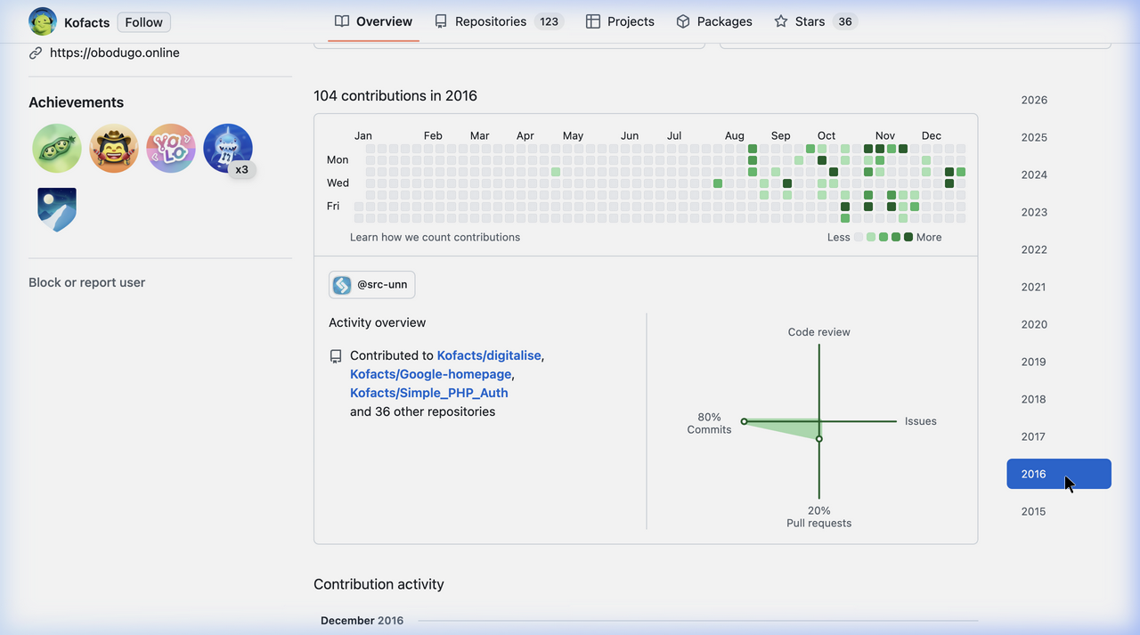
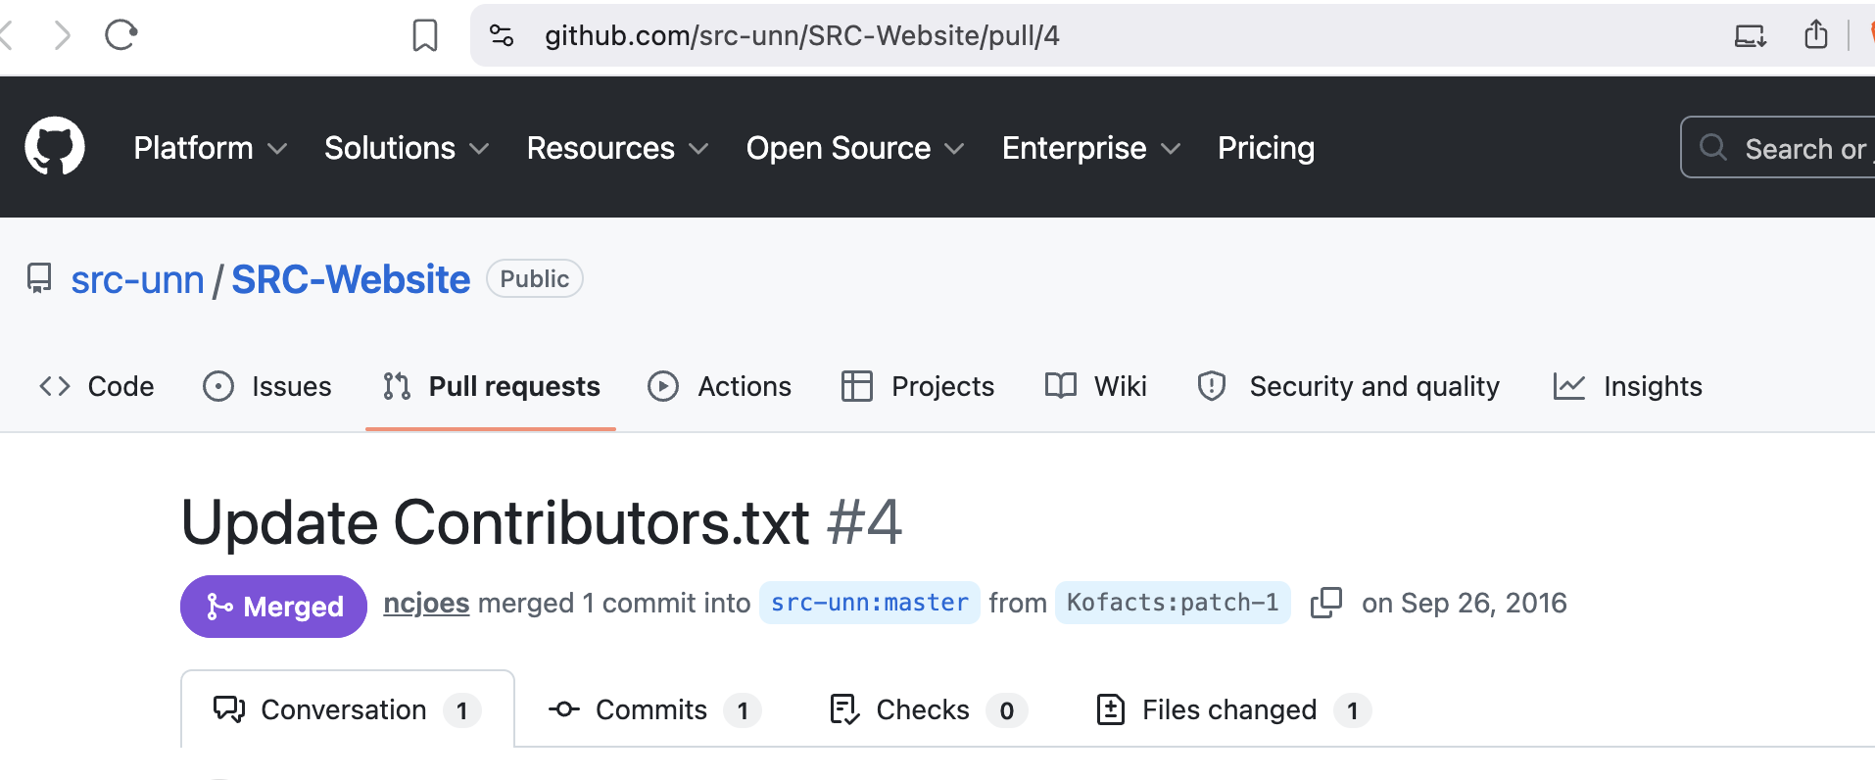
- i18n-node (3.1k+ ⭐): Driving architectural localization standards by resolving deep-seated technical debt across 5 major enterprise-grade issues.
- Sustained, voluntary sector advancement since 2016, validated by merged contributions to community-led academic and digital ecosystems (SRC-Website / analite-digital).

